COAL Lab 07 Assignment:

# Name: Owais Ali Khan

# Section: 3-F

# Roll no: 21K-3298

Question # 01:

TITLE Question 01

Include Irvine32.inc

.data

var DWORD ?

.code

main PROC

mov var, 5

mov ecx, 4

cmp var, ecx

jl IFF

mov var, 1

jmp ENDIFF

IFF:

mov var, 0

ENDIFF:

mov eax, var

call DumpRegs

exit

main ENDP

END main

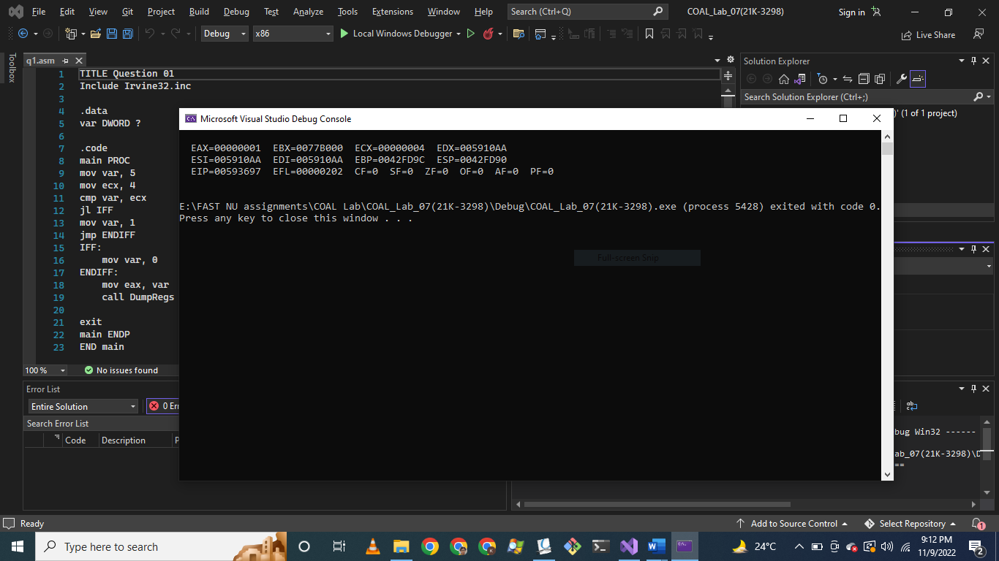

Question # 02:

TITLE Question 02

Include Irvine32.inc

.data

intArr SWORD 0, 0, 0, 0, 1, 20, 35, -12, 66, 4, 0

message BYTE "The first non-zero value in given array is: ", 0

.code

main PROC

mov esi, OFFSET intArr

mov eax, 0

mov ecx, LENGTHOF intArr

L1:

mov ax, SWORD PTR [esi]

cmp ax, 0

jg FOUND

add esi, TYPE intArr

loop L1

jmp ENDD

FOUND:

mov edx, OFFSET message

call WriteString

call WriteInt

call Crlf

ENDD:

exit

main ENDP

END main

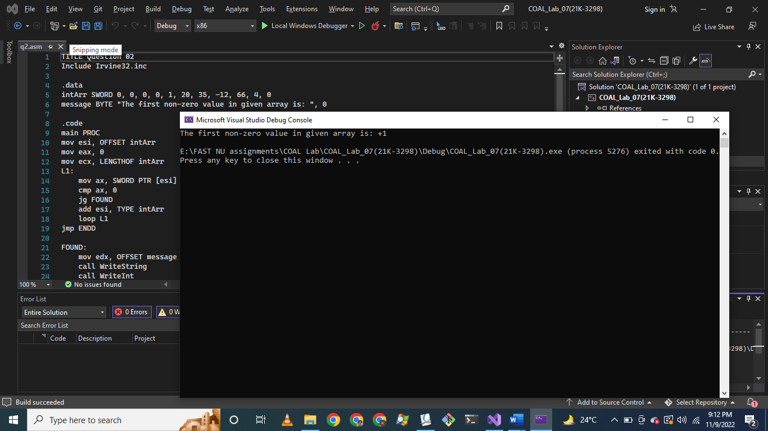

Question # 03:

TITLE Question 03

Include Irvine32.inc

.data

values DWORD 4 DUP(0)

msgEqual BYTE "The given four values are all equal.", 0

msgNotEqual BYTE "The given four values are not equal.", 0

msg BYTE "Enter value: ", 0

.code

main PROC

mov eax, 0

mov esi, 0

mov edx, OFFSET msg

mov ecx, LENGTHOF values

L1:

call WriteString

call ReadInt

mov values[esi], eax

add esi, TYPE values

loop L1

mov esi, 0

mov ecx, 3

L2:

mov eax, values[esi]

cmp eax, values[esi + TYPE values]

jne L3

add esi, TYPE values

loop L2

mov edx, OFFSET msgEqual

call WriteString

call Crlf

jmp ENDD

L3:

mov edx, OFFSET msgNotEqual

call WriteString

call Crlf

ENDD:

exit

main ENDP

END main

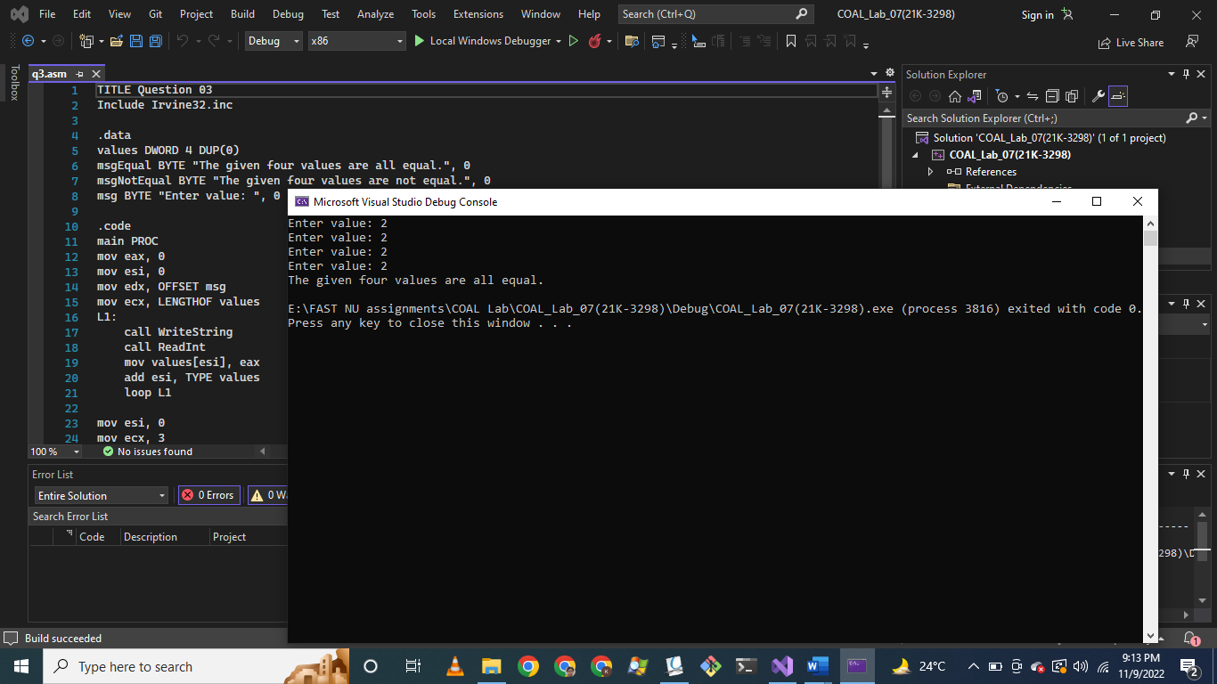

Question # 04:

TITLE Question 04

Include Irvine32.inc

.data

arr WORD 10, 4, 7, 14, 299, 156, 3, 19, 29, 300, 20

msg BYTE "Enter key to search for: ", 0

msg2 BYTE "Key found: ", 0

msg3 BYTE "Key not found.", 0

msg4 BYTE " at index: ", 0

.code

main PROC

mov eax, 0

mov edx, OFFSET msg

call WriteString

call ReadInt

movzx ebx, ax

mov esi, 0

mov ecx, LENGTHOF arr

L1:

mov ax, arr[esi * TYPE arr]

cmp ax, bx

je FOUND

inc esi

loop L1

mov edx, OFFSET msg3

call WriteString

call Crlf

jmp ENDD

FOUND:

mov edx, OFFSET msg2

call WriteString

call WriteInt

mov edx, OFFSET msg4

call WriteString

mov eax, esi

call WriteDec

call Crlf

ENDD:

exit

main ENDP

END main

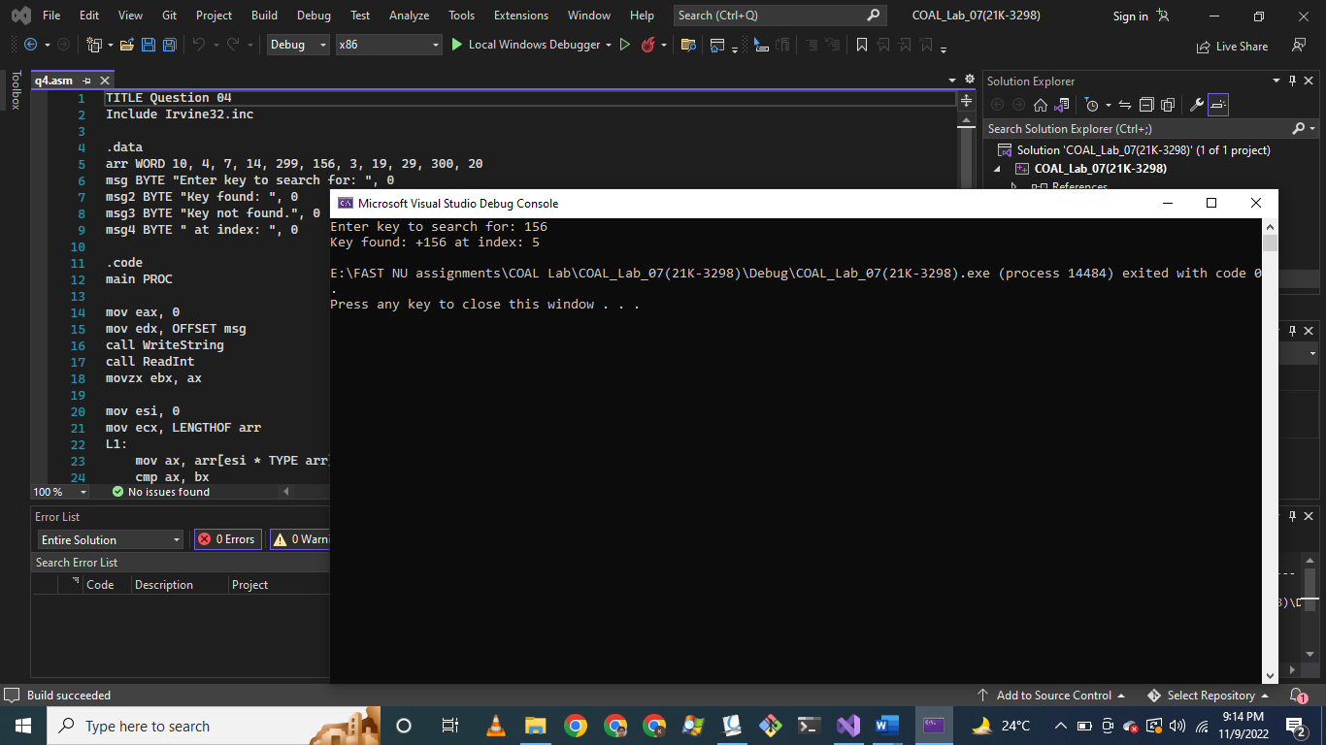

Question # 05:

TITLE Question 05

Include Irvine32.inc

.data

array DWORD 10, 4, 7, 14, 50

space DWORD " "

swapCount DWORD 0

msg BYTE "Total number of swaps: ", 0

.code

main PROC

mov eax, 0

mov esi, 0

mov ecx, LENGTHOF array

PRINT:

mov eax, array[esi]

call WriteDec

mov eax, space

call WriteChar

add esi, TYPE array

loop PRINT

call Crlf

mov esi, 0

mov ecx, (LENGTHOF array - 1)

L1:

mov eax, array[esi]

cmp eax, array[esi + TYPE array]

jg SWAP

jmp endd

SWAP:

xchg eax, array[esi + TYPE array]

inc swapCount

ENDD:

add esi, TYPE array

loop L1

mov edx, OFFSET msg

call WriteString

mov eax, swapCount

call WriteDec

exit

main ENDP

END main

